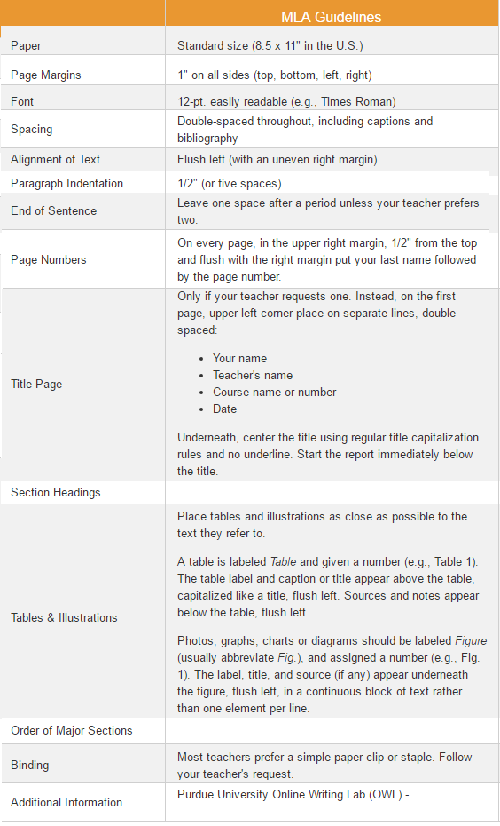

[MLA Style Guide](https://owl.english.purdue.edu/owl/resource/747/01/)