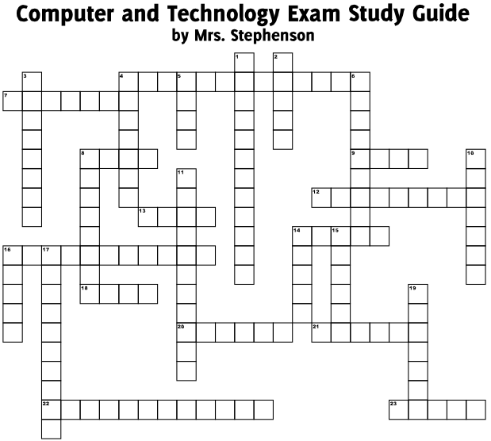

Across
4 An unknown person continuously sending you abusive emails is an example of _______________________.
7. Which tab in the Format Picture window has options to crop an image?
8. Tim wants to arrange all of his school basketball team members in alphabetical order. Which option will best help him do so?
9. After registering on a social-networking site, you receive one or two emails every day about promotional offers as well as friend requests from strangers. Which email abuse have you fallen victim to?
12. It is a good idea to use underline _________ because it is commonly associated with hyperlinks
13. Times New Roman is a ____ style that should NOT be used in a presentation.
14. Which port can connect you to the Internet through a telephone line?
16. The Track Changes feature is turned on when you open the Tools menu, click Track Changes, and then highlight changes in a ___________________.
20. By selecting _________ in the table menu you can add a table, rows, columns, or cells.
21. The title of the document is commonly inserted in the ________ of a document.
22. The best way to avoid spyware is to avoid installing ____________ online software.
23. Software updates that close security loopholes by fixing bugs and vulnerabilities.

Down
1. “Do you like mustard on sandwiches?” is an example of a ___________________ question.
2. One limitation of a _______ memory card is that you can only use it with the correct memory card reader.
3. ___________ software is designed to prevent malicious software from accessing your computer.
4. A feature of a strong thesis statement is that it answers the _________ question.
5. What is the last step in the process before preparing to present a presentation?
6. Sam wants to modify an image so it isn’t stark black-and-white but has gradations. What color option should he apply to the image?
8. The _______ toolbar displays options such as Cut and Paste.
10. A software program that secretly gathers information about users while they navigate the internet.
11. In order to select _____________ rows in a worksheet you will click the heading of the first row in the selection, hold down the shift key, and click the heading of the last row in the selection.
14. One disadvantage of a pie chart is that you cannot differentiate ________ differences within the chart.
15. To open a program on your desktop ________-click on the program icon.
16. The key combination Ctl+S _____ the file.
17. Where can John retrieve a file that he has accidentally deleted?
19. The _________ =SUBTRACT (B3:B4) should be used to find the difference in the height of two students.

Mulitiple choice:

24. Computers story temporary Internet files in the Recycle Bin. These files take up space and slow down a computer. Which tool can be used to remove these unwanted files?
- Scan disk
- Disk Cleanup
- Disk Defragmenter

25. Which of these actions would NOT help you organize data efficiently?
- Storing all your programs or applications in the Program folder
- Storing all your personal and school files in the My Documents folder
- Storing files on your desktop so that you can locate them easily

26. In which scenario would instant messaging be more useful than other forms of communication?
- Jane, Joey, and Rebecca are assigned to work on a project together. Jane has a different schedule and needs to be updated on what Joey and Rebecca accomplished today.
- Sue and Shae are waiting for Roy at the movie theater. Both of them are carrying cell phones with Internet connectivity.
- Serena and Sharon are doing their math homework in their own homes. They need help from each other to complete the task.

27. Emily has to create an audio-visual presentation on animated movies. Which input device will she be LEAST likely to use while creating her presentation?
- Keyboard
- Joystick
- Microphone
- Mouse

28. Which is the most efficient way to italicize a row of text in every worksheet in a workbook?
- Drag your cursor across the sheet tabs to select all of the worksheets. Next, select the row you want to italicize and click the Italics icon on the Formatting toolbar.
- Right-click the sheet tab bar and click Select All. Next, select the row that you want to italicize and click the Italics icon on the Formatting toolbar.
- Select the row that you want to italicize and click the Italics icon on the Formatting toolbar. Next, right-click the sheet tab bar and click Select All.
- Select the row that you want to italicize and click the Italics icon on the Formatting toolbar. Repeat this process in each worksheet.

